**Risk-based evaluations of competing agronomic options for climate adaptation: The case of rice planting strategies in the Indo Gangetic Plains**

# Abstract

Adjusting crop planting dates and variety durations is emerging as a crucial climate change adaptation strategy for many cereal systems. Such strategies include, for example, harmonizing crop planting with the onset of the rainy season or planting at specific recommended calendar dates. Evaluations of these strategies mostly consider yield and yield variability, but focus less on financial risks associated with different planting strategies. However, choosing recommendations amongst competing levels of yield and yield stability is not straightforward as preferences for yield increases and stability might differ. Here, we present a novel framework that uses a computational spatial economics approach for evaluating which planting strategies work best where. To demonstrate our approach – we evaluate readily available gridded crop simulation outputs for various rice crop planting strategies for the rice-wheat systems of the Indo-Gangetic Plains. Our findings provide quantitative evidence to the previous conclusion that harmonizing the planting dates of long-duration varieties at the monsoon onset works best in the Eastern IGP, this strategy fail and is clearly outperformed by planting rice at state-recommended planting dates in most of the Western and Middle IGP. Importantly, our risk-based assessment shows that the results are not as clear cut in the northern Middle IGP where farmers appear to have more flexibility to achieve comparable outcomes. In conclusion, our approach provides a useful and novel tool for comparing different agronomic climate adaptation strategies from an economic risk perspective in a spatial framework.

# 1. Introduction

Climate change is predicted to have a largely negative impact on the agricultural systems of low-income countries (IPCC, 2022). To adapt, farmers and policy makers must choose between several competing agronomic response options. Researchers usually evaluate these options based on average yield levels, water use, and income across years with varying weather conditions and provide subsequent recommendations. However, comparing these different indicators and assessing acceptable levels of variability is not straightforward resulting in recommendations based on qualitative expert judgement. This is especially the case for risk averse smallholder farmers that seek to minimize any losses they may have to incur. How, for example, shall one evaluate an adaptation strategy that, across several years, has been shown to require an average of 50mm additional water use to gain 300 kg of yield, 10% more income and increase yield variability by 5%?

Deriving recommendations for rice planting in the rice-wheat cropping systems of the Indo-Gangetic Plains (IGP) is a case in point. In the IGP, rice is planted in the monsoon season from June to October (also called kharif) while wheat is grown as an irrigated crop in winter season from November to April (also called rabi). Climate impacts on agricultural systems of the IGP are amongst the most severe globally (IPCC, 2022), as, e.g., late monsoon onsets delay rice sowing in the Eastern IGP and push wheat crops into periods of high terminal heat stress – while farmers in the Western IGP use free electricity to plant their rice crops early in the hot summer months and contribute groundwater depletion. Recent compelling evidence (e.g., McDonald et al 2022, Urfels et al 2022, and Montes et al 2022) suggests that advancing the planting date of rice is to match the monsoon onset is one of the viable adaptation options for farmers in the Eastern IGP – and might help to alleviate groundwater depletion in the Western IGP. To test this hypothesis, Urfels et al (2022) and Montes et al (2022) used gridded crop simulations for the Indo-Gangetic Plains to investigate the impact of different rice planting strategies (combining sowing dates, variety duration and irrigation) on system level productivity, resilience, and environmental benefits. However, most farmers are risk averse and not only interested in long-term profit maximization and yield outcomes. It is thus important to consider economic risks and not just average yield and yield variability is critical for evaluating agronomic adaptation strategies. For example, recent studies (see, Hurley et al 2018, Suri 2011) have shown that year to year variation in economic returns to adopting technologies can to result in lower levels of adoption of generally profitable agricultural innovations – but approaches for evaluation agronomic strategies from a risk perspective remain scarce.

To address this knowledge gap, we develop a robust and risk-oriented framework to select suitable adaptation strategies for risk-averse farmers. To demonstrate our approach, we extend the evaluation of the crop modelling results for different rice planting strategies across the IGP of Urfels et al. (2022) and evaluate them through our novel risk-oriented framework.

This paper contributes to two strands of literature. The first strand of literature is on stability analyses of agricultural technology benefits based on ex-ante cropping system assessments (e.g., Urfels et al 2022, Montes et al 2022). Montes et al (2022) used inter-annual standard deviation to analyze the stability of the planting date scenarios. Urfels et al (2022) used deviation from the mean caloric yield for each of the years when a shock occurred as a measure of yield instability. These measures of yield stability while a step better than mean comparisons, they do not consider robustness of the optimal decision to risk aversion of the farmers. In addition, these measures do not consider higher order moments beyond mean and variability that may matter for distributional comparisons. In addition, we argue that stability analyses just as comparisons of means do not consider the trade-offs of achieving the highest returns with the lowest uncertainty. While uncertainty of modelling has been addressed by, for example, using model ensembles or monte carlo simulations, these only allow for stronger confidence in the mean and variation around it – but do not take into account farmers’ risk preferences.

These limitations are addressed in the second strand literature which focuses on the spatial risk assessment of economic benefits of agricultural innovations (e.g., Nalley and Barkley 2010, Hurley et al 2018). This literature attempts to optimize on the trade-offs of achieving the highest return and lowest uncertainty therefore allows one to choose strategies that are more robust. Using modern portfolio theory (Markowitz 1959) which suggests that a strategy to maximize average returns may be a suboptimal strategy, Nalley and Barkley (2010) used a mean-variance analysis to optimally select wheat varieties that achieve highest return and lowest risk. This strategy still suffers from the limitation of using a subset of moments (mean and variance) of the distribution. The stochastic dominance approach was developed to resolve these concerns in selecting robust strategies (Levy 2016). Using long term weather data, crop simulation model results (APSIM), spatially explicit observed maize prices, and fertilizer prices; Hurley et al (2018) simulates whether weather risk affects the adoption of fertilizer and improved maize seeds. They use heterogeneity in soils and climate in a calibrated crop growth model to simulate the distributions of yields across adoption of fertilizer and improved maize seed scenarios. They also assessed the heterogeneity of farmer risk preferences.

We specifically follow the approach proposed by Hurley et al (2018) to estimate willingness to pay bounds for a risk averse farmer to likely adopt an alternative rice planting date strategy. We depart from their approach in two substantial ways. First, instead of fertilizers and improved varieties, we consider multiple management changes including sowing dates, irrigation amounts, and varieties differing on duration to maturity. Second, we consider a rice-wheat multi-crop system unlike Hurley et al (2018) who focus on maize only. Our application shows how this risk-assessment framework can handle increasingly complex decisions.

The rest of the paper is organized as follows. We present next the methods focusing on the computational risk assessments. In section 3 we present results and discussion of the yield and economic benefits of alternative planting date strategies. We finally conclude in section 4.

# 2. Methods

To present our risk-assessment framework for comparing different adaptation options for risk-averse farmers, we use the gridded APSIM simulation outputs from Urfels et al. (2022). We then compare the different options regarding their economic performance and riskiness. To assess economic returns, we multiply the simulated yield outcomes with spatially explicit price data for rice and wheat. Since the only variable cost of in the simulation is irrigation amount, we consider their impact on the outputs and calculate partial profits using common irrigation cost of XX per m3 and multiply it with the total irrigation amount required in each simulation. Next, we use a novel method to estimate willingness to pay bounds through a stochastic dominance approach to determine which rice planting strategies are both economically beneficially and least risky. The remainder of this Methods section provides an overview of (i) the input data and (ii) our risk assessment approach.

## 2.1. APSIM spatially gridded crop model scenarios

The data used in this paper was based on gridded APSIM crop growth simulation model results for climate variables for the period 1982-2015 reported in Urfels et al (2022) and Montes et al (2022).[[1]](#footnote-2). We use seven scenarios from crop simulation results reported in Urfels et al (2022). The scenarios correspond to variation in irrigation, varietal duration and the planting of rice at the onset of the monsoon. Table 1 shows the details for the scenarios.

Table 1: Scenarios

|  |  |  |
| --- | --- | --- |
| Scenario number | Rice planting strategy | Description |
| S0 | Farmer practice | Farmers’ practice baseline without nutrient and water limitations to understand current limits |
| S1 | Fixed long (baseline) | Planting long duration variety at a fixed recommended date (state recommendation) |
| S2 | Fixed medium | Planting medium duration variety at a fixed recommended date |
| S3 | Onset long | Planting long duration rice variety at the onset of monsoon |
| S4 | Onset long supp | Only providing supplementary irrigation for planting long duration varieties at monsoon onset |
| S5 | Onset medium | Planting medium duration variety at monsoon onset |
| S6 | Onset medium supp | Supplementary irrigation for planting medium varieties at monsoon onset |

We supplement the APSIM model results with spatially gridded rice and wheat prices from the Landscape Crop Assessment Survey (LCAS; <https://systems-agronomy.github.io/lcas/>) data interpolated using a random forest model and back of the envelope spatially gridded irrigation costs.

## 2.2. Computational spatial ex-ante economic model under risk aversion

Our framework uses a two-step approach, first evaluating systems-level yield risks and subsequently systems level economic risks. For both yield risks and economic risks, we assess adaptation options through a willingness to pay (WTP) lens that considers both economic performance and riskiness. The guiding question is: How much would a farmer be willing to pay for an adaptation option and still be clearly better off than with the baseline? To assess this, we assume that an adaptation option is suitable for risk averse farmers if the distribution (not just the average) of yield and economic outcomes supersedes the baseline. Using the so called ‘second order stochastic dominance’ (SOSD) – a well-established measure in decision theory for comparing the riskiness inherent in two distributions – we assess whether the adaptation option is less risky than the baseline (i.e. negative outcomes less likely).Below we provide an overview of how SOSD works for our case. For more details regarding SOSD and risk aversion, please see Levy (2016) and Meyer (1977) for a detailed explanation.

### 2.2.1. Comparing the riskiness of two agronomic adaptation options

To evaluate the riskiness of an adaptation option regarding either yield or economic returns, we compute spatially explicit willingness to pay bounds in rice and wheat yield equivalents that define, for a risk averse farmer, whether that farmer would adopt a technology or not. While SOSD provides an estimate of which option is risker – we use Hurley et al.’s (2018) approach to further asses how much better it is. In principle, the WTP bounds indicate (i) how much the cumulative distribution of the adaptation option can be shifted to the left (i.e. the benefits uniformly reduced) and still outperform the baseline (lower bound), and (ii) how much the cumulative distribution function can be moved to the right (i.e. the benefits uniformly increased) before it is entirely on the right side of the baseline (upper bound). That is, the lower bound provides a measure of how distant the two adaptation options are in terms of riskiness, while the upper bound provides a measure of how close the option is to fully superseding the baseline (zero risk).

To demonstrate this approach,

we use a hypothetical experiment shown in Figure 1. Based on mean comparisons, $G$ is clearly better than $F$ and $Q$. If we think in terms of distributional differences, $G$ is clearly better than $Q$ because the cumulative distribution curve of $G$ is wholly to the right of $Q$. This is also called first order stochastically dominance. Consider the next case, where $G$ and $F$ are having crossing cumulative distribution functions. Visually, it can be assessed that $G$ has a higher mean and much lower likelihood of low performing outcomes. G has a higher mean and is less risk. This is, G second order stochastically dominates $F$. Since the cumulative distribution function of G and F are crossing each other, neither distribution first order stochastically dominates the other.

Lastly, consider the case of $F$ and $Q$, they are crossing each other and have the same mean. It is difficult to visually assess which one is more risky – i.e. determine the second order stochastic dominance ordering for these technologies.

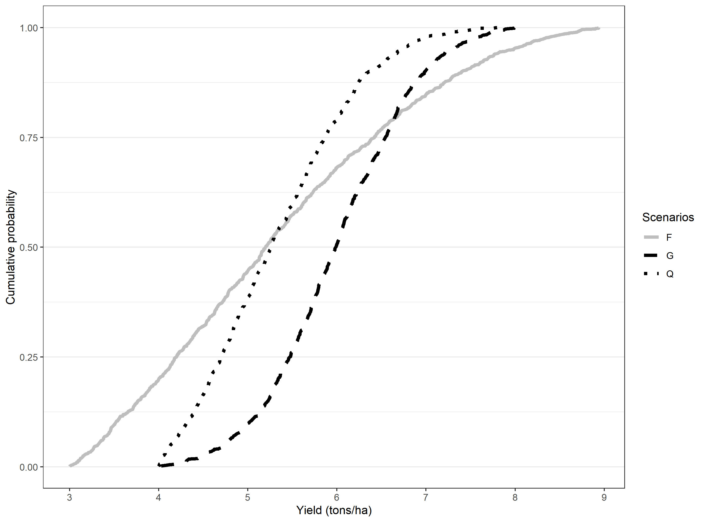

Figure 1: Hypothetical stochastic dominance assessment

***Note:*** We use a truncated normal distribution with four parameters: minimum (a), maximum (b), mean, and standard deviation (sd). The parameters used for each of the scenarios are as follows: G= rtruncnorm (n=1000,a=4,b=8, mean=6,sd=0.8), Q=rtruncnorm (n=1000,a=4,b=8, mean=5,sd=1), F=rtruncnorm (n=1000,a=3,b=9, mean=5,sd=2).

The lower WTP bound that makes any risk-averse farmer prefer new technology (in this case scenarios other than the baseline) can be derived using second order stochastic dominance (see Hurley et al 2018 for detailed derivations). If both lower bound and upper bound are positive, then any risk averse farmer will prefer the new technology. Conversely, if both lower bound and upper bound are negative, then any risk averse farmer will stick to the old technology. If however, the lower bound is negative and the upper bound is positive, then it is requires an explicit understanding of risk preferences—information not easily available—to determine which distribution is preferred. We use Octave for the computational analyses.

Proceeding with the hypothetical distributions, we show in table 2 results from using our approach to compute upper and lower willingness to pay bounds. The WTP bounds are positive for the comparison between Q and G as well as F and G.

Table 2: Hypothetical distributions and willingness to pay bounds

|  |  |  |  |
| --- | --- | --- | --- |
| Panel (a): Truncated normal distribution parameters for the hypothetical distributions | | | |
| Truncated normal parameters | G | Q | F |
| N | 1000 | 1000 | 1000 |
| Min=a | 4 | 4 | 3 |
| Max=b | 8 | 8 | 9 |
| Mean | 6 | 5 | 5 |
| SD | 0.8 | 1 | 2 |
| Panel (b): Willingness to pay bounds from computational second order stochastic assessment | | | |
|  | Q(base)  vs G | Q vs F | F vs G |
| WTP lower bound (t/ha) | 0.036 | 0 | 0.499 |
| WTP upper bound (t/ha) | 0.763 | 0.218 | 1.384 |
| Interpretation | G F/SOSD Q | Not clear | G SOSD F |

The sign for the WTP bounds gives the evaluation of the benefits of the technology for a risk averse farmer. If both upper and lower bounds are positive, the farmer is willing to pay for that strategy. The upper bound is the amount of money that would pay just to stay with the new technology, while the lower bound is the amount that would pay just to be indifferent between the new strategy and the base strategy. For negative WTP for upper and lower bound, it shows that they would need to be paid to accept the proposed strategy. Lower bound is the amount of money that they would accept to abandon their existing strategy. Upper bound is the amount of money that they would accept just to be indifferent between the new strategy and their existing strategy.

### 2.2.3. System economic benefits under risk

For cropping system assessment, we focus on the revenues and partial profits (revenue-cost of irrigation) derived from both rice and wheat. Willingness to pay is therefore in monetary terms rather that quantity terms. We use the same approach as stated above to determine if it is beneficial for a risk averse farmer to adopt the planting date strategy. When the revenue WTP is compared to cost of production differences between the baseline and the proposed strategy, we get the profit potential for the farmers in each pixel.

# 3. Results

Here we present our results to evaluate the yield and economic risks associated with different rice planting strategies that were simulated across the Indo-Gangetic Plains. We first present results for rice and wheat yields and subsequently assess the performance for system level economic returns and their risks. We use the state recommended calendar dates for rice planting (not the farmers’ practice) as it is a more clear cut strategy than the remotely sensed farmer’s practice.

## 3.1. Yield benefits over baseline for risk averse farmer

### 3.1.1. Rice

Table 3 shows the descriptive statistics on the willingness to pay bounds (ton/ha) in rice yield equivalent for the planting date scenarios in comparison to the fixed date with long duration variety planting strategy. The WTP summary rows show the percentage of farmers who are more likely to benefit, be worse off or be indifferent between the planting date strategies. Only 31% of the farmers would find the onset long as beneficial followed by fixed medium (30%). For farmer practice, the average and median WTP bounds (both lower and upper) are negative implying that farmers will have to be paid to be indifferent or prefer it as compared to fixed date with long duration variety planting strategy.

Table 3: Rice WTP bounds with fixed long as baseline, IGP

|  |  |  |  |  |  |  |  |
| --- | --- | --- | --- | --- | --- | --- | --- |
| Bound | Statistics | S0-S1 | S2-S1 | S3-S1 | S4-S1 | S5-S1 | S6-S1 |
| Upper bound | Mean | -1.03 | 1.90 | 0.76 | 0.41 | 1.32 | 1.01 |
| Std.Dev | 1.36 | 1.75 | 2.50 | 2.38 | 1.79 | 1.76 |
| Min | -5.65 | -2.47 | -5.58 | -5.65 | -4.23 | -4.38 |
| 10th percentile | -2.17 | -1.60 | -2.26 | -2.35 | -1.65 | -1.53 |
| 25th percentile | -1.85 | 1.32 | -0.58 | -0.88 | 0.66 | -0.47 |
| Median | -1.33 | 2.48 | 0.04 | -0.30 | 1.77 | 1.53 |
| 75th percentile | -0.45 | 3.04 | 3.18 | 2.86 | 2.38 | 2.20 |
| 90th percentile | 0.15 | 3.52 | 4.11 | 3.68 | 3.06 | 2.93 |
| Max | 5.92 | 5.64 | 5.73 | 5.65 | 10.95 | 8.90 |
| Lower bound | Mean | -3.53 | -0.73 | -1.42 | -2.02 | -1.27 | -1.49 |
| Std.Dev | 1.68 | 1.73 | 2.60 | 2.47 | 1.78 | 1.68 |
| Min | -7.83 | -4.69 | -7.02 | -6.16 | -7.02 | -7.20 |
| 10th percentile | -5.53 | -2.47 | -5.13 | -5.19 | -2.75 | -3.20 |
| 25th percentile | -4.62 | -2.03 | -3.76 | -4.41 | -2.28 | -2.52 |
| Median | -3.71 | -1.15 | -0.71 | -1.87 | -1.51 | -1.82 |
| 75th percentile | -2.32 | 0.35 | 0.18 | -0.14 | -0.34 | -0.54 |
| 90th percentile | -1.89 | 1.92 | 1.90 | 1.18 | 1.16 | 0.73 |
| Max | 4.84 | 5.05 | 4.79 | 4.66 | 8.50 | 6.49 |
| WTP summary | Clearly better (share) | 0.02 | 0.30 | 0.31 | 0.21 | 0.21 | 0.18 |
| Not clear (share) | 0.11 | 0.52 | 0.21 | 0.19 | 0.59 | 0.53 |
| Clearly worse (share) | 0.87 | 0.18 | 0.49 | 0.60 | 0.21 | 0.29 |
| Number of cells | 17411.00 | 17412.00 | 17420.00 | 17421.00 | 17421.00 | 17421.00 |

Note: The number of cells are lower for S0-S1, S2-S1 and S3-S1 due to missing information in some of the pixels.

Figure 2 shows the spatial clustering of pixels for which the proposed planting strategy is clearly better, better or worse and clearly worse than the fixed calendar date state recommendation with long duration variety strategy. Among these, planting with monsoon onset with a long duration strategy seems to provide much advantage in the eastern part of IGP. The western part seems to benefit more from the fixed date recommendation with long duration variety.

Figure 2: Willingness to pay **(rice yield t/ha)** for the strategy against a fixed long duration variety reference strategy using second order stochastic dominance

### 3.1.2. Wheat

Table 4 shows descriptive statistics of the willingness to bounds in wheat yield equivalent (t/ha) for the scenarios in comparison to fixed date recommendation with long duration rice variety rice planting strategy (here after called fixed long strategy). Column (S0-S1) shows the comparison between farmer practice and fixed long strategy. It is apparent from the lower bound estimates, almost 90% of farmers have negative WTP lower bound for the farmer practice strategy when compared with the fixed long strategy. For about 25% of these, even the upper WTP is negative. Farmer practice is good strategy for risk averse farmers for only about 4% of the pixels. For wheat the best strategy seems to be fixed medium rice planting strategy in that most of pixels (86%) will benefit with higher wheat yields as compared to the fixed long rice planting strategy.

Table 4: Wheat WTP bounds (ton/ha) with fixed date-long variety scenario as baseline, IGP

|  |  |  |  |  |  |  |  |
| --- | --- | --- | --- | --- | --- | --- | --- |
| Bound | Statistics | S0-S1 | S2-S1 | S3-S1 | S4-S1 | S5-S1 | S6-S1 |
| Upper bound | Mean | -0.50 | 1.00 | 0.22 | -0.88 | 0.17 | -0.65 |
| Std.Dev | 0.83 | 0.46 | 0.64 | 1.19 | 0.70 | 1.14 |
| Min | -5.47 | -0.08 | -1.16 | -4.06 | -1.56 | -4.19 |
| 10th percentile | -1.89 | 0.28 | -0.58 | -2.55 | -0.76 | -2.19 |
| 25th percentile | -0.71 | 0.71 | -0.18 | -1.78 | -0.42 | -1.63 |
| Median | -0.29 | 1.09 | 0.08 | -0.79 | 0.20 | -0.50 |
| 75th percentile | 0.00 | 1.34 | 0.54 | -0.06 | 0.75 | 0.29 |
| 90th percentile | 0.28 | 1.53 | 1.28 | 0.77 | 1.11 | 0.75 |
| Max | 1.59 | 1.99 | 2.05 | 1.91 | 1.78 | 1.61 |
| Lower bound | Mean | -1.94 | 0.49 | -0.37 | -1.69 | -0.37 | -1.62 |
| Std.Dev | 1.45 | 0.37 | 0.83 | 1.45 | 0.79 | 1.47 |
| Min | -7.00 | -0.55 | -2.29 | -6.67 | -2.29 | -6.67 |
| 10th percentile | -3.88 | -0.02 | -1.49 | -3.69 | -1.50 | -3.65 |
| 25th percentile | -3.15 | 0.27 | -0.90 | -2.97 | -1.01 | -2.83 |
| Median | -2.14 | 0.49 | -0.37 | -1.64 | -0.21 | -1.70 |
| 75th percentile | -0.58 | 0.70 | 0.15 | -0.52 | 0.28 | -0.17 |
| 90th percentile | -0.04 | 1.07 | 0.79 | 0.29 | 0.47 | 0.24 |
| Max | 1.34 | 1.34 | 1.62 | 1.49 | 1.35 | 1.23 |
| WTP summary | Clearly better (share) | 0.04 | 0.86 | 0.28 | 0.15 | 0.40 | 0.20 |
| Not clear (share) | 0.20 | 0.12 | 0.35 | 0.09 | 0.19 | 0.14 |
| Clearly worse (share) | 0.75 | 0.01 | 0.37 | 0.76 | 0.41 | 0.66 |
| Number of cells | 17421.00 | 17421.00 | 17421.00 | 17421.00 | 17421.00 | 17421.00 |

Figure 3 shows the spatial distribution of willingness to pay classifications categorizing strategies on wheat yield whether they are worse, better or worse, and better than the fixed long rice planting strategy. Fixed planting of a medium duration rice variety seems to be the best strategy to ensure higher wheat yields across all locations most locations in IGP except the northwestern side where one would be indifferent (12%).

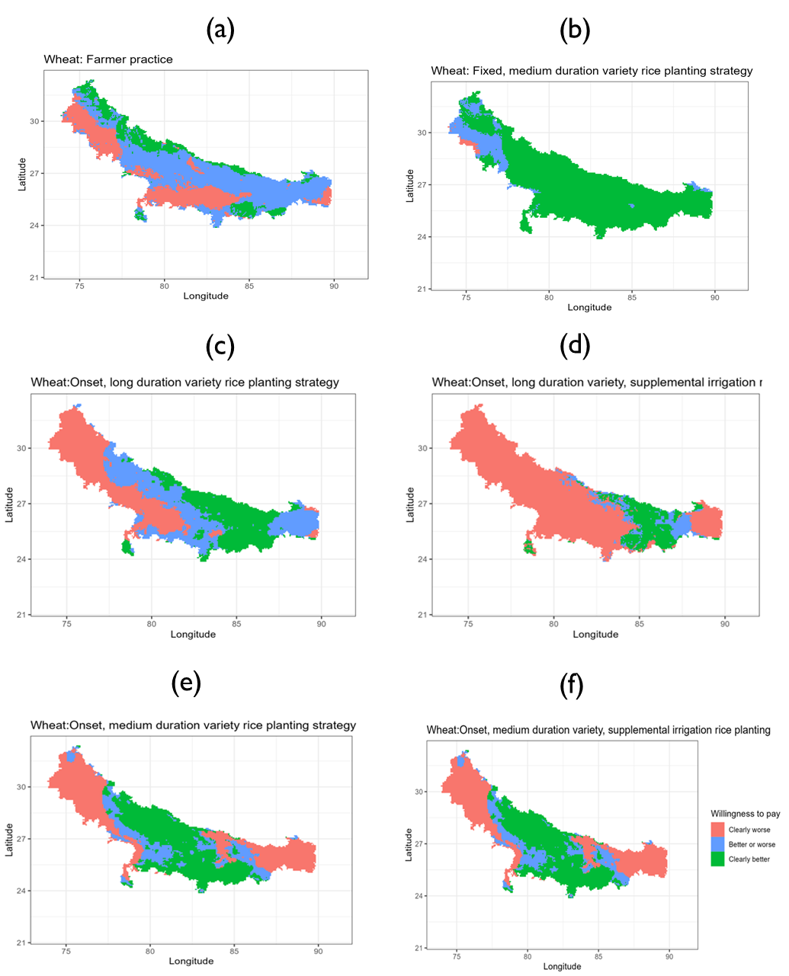

Figure 3: Willingness to pay (wheat yield t/ha) for the strategy against a fixed long duration variety reference strategy using second order stochastic dominance.

## 3.2. System-wide economic benefits for a risk averse farmer

### 3.2.1. System revenues

The approach involves using pixel level prices of rice and wheat to compute the revenues of following each of the scenarios. The pixel level prices are obtained by interpolating prices from the Landscape Diagnostic Survey (LDS) for 2017/18 season. We then use these economic indicators in the stochastic comparisons. Table 5 shows the descriptive statistics for the willingness to pay bounds. Starting with the percentage of pixels that would benefit from each of the scenarios as compared to the baseline, the statistics rows show that strategies are worse for farmers across most of the pixels are farmer practice (column 3) with 78% losing and onset medium with constrained irrigation (column 8) with 49% losing.

Table 5: Gross revenue WTP (thousand ruppes/ha) bounds with fixed long as baseline

|  |  |  |  |  |  |  |  |
| --- | --- | --- | --- | --- | --- | --- | --- |
| Bound | Statistics | S0-S1 | S2-S1 | S3-S1 | S4-S1 | S5-S1 | S6-S1 |
| Upper bound | Mean | -23.99 | 34.99 | 8.37 | -14.67 | 14.30 | 1.49 |
| Std.Dev | 25.96 | 28.30 | 41.11 | 47.53 | 29.59 | 31.35 |
| Min | -144.09 | -28.54 | -84.72 | -125.24 | -64.90 | -89.49 |
| 10th percentile | -56.03 | -15.52 | -45.24 | -74.99 | -26.87 | -37.83 |
| 25th percentile | -39.27 | 22.03 | -19.37 | -51.28 | -4.45 | -19.90 |
| Median | -24.18 | 41.04 | 1.34 | -18.60 | 15.28 | -1.92 |
| 75th percentile | -12.33 | 56.10 | 39.14 | 20.11 | 36.06 | 25.19 |
| 90th percentile | 1.85 | 66.82 | 69.81 | 56.16 | 53.93 | 45.26 |
| Max | 87.55 | 91.16 | 96.57 | 86.07 | 132.20 | 108.48 |
| Lower bound | Mean | -73.43 | -1.39 | -18.36 | -43.68 | -16.67 | -28.19 |
| Std.Dev | 36.34 | 25.91 | 43.02 | 49.08 | 28.35 | 30.59 |
| Min | -177.76 | -59.94 | -123.07 | -139.93 | -119.55 | -151.45 |
| 10th percentile | -113.83 | -28.09 | -77.92 | -109.68 | -46.58 | -65.46 |
| 25th percentile | -94.35 | -20.99 | -53.41 | -86.66 | -30.70 | -43.60 |
| Median | -72.95 | -6.29 | -13.44 | -42.45 | -19.58 | -29.30 |
| 75th percentile | -56.20 | 16.31 | 10.49 | -3.30 | -1.85 | -11.96 |
| 90th percentile | -29.14 | 36.79 | 37.99 | 22.05 | 20.96 | 11.44 |
| Max | 83.40 | 69.35 | 87.03 | 76.56 | 113.90 | 83.34 |
| WTP summary | Clearly better (share) | 0.02 | 0.42 | 0.36 | 0.23 | 0.23 | 0.16 |
| Not clear (share) | 0.09 | 0.42 | 0.16 | 0.14 | 0.44 | 0.32 |
| Clearly worse (share) | 0.89 | 0.16 | 0.48 | 0.63 | 0.32 | 0.52 |
| Number of cells | 17456.00 | 17456.00 | 17456.00 | 17456.00 | 17456.00 | 17456.00 |

Spatially, there are pockets for which a risk averse farmer would not switch to the recommended fixed date with long duration variety strategy especially in the central pixels of Bihar.

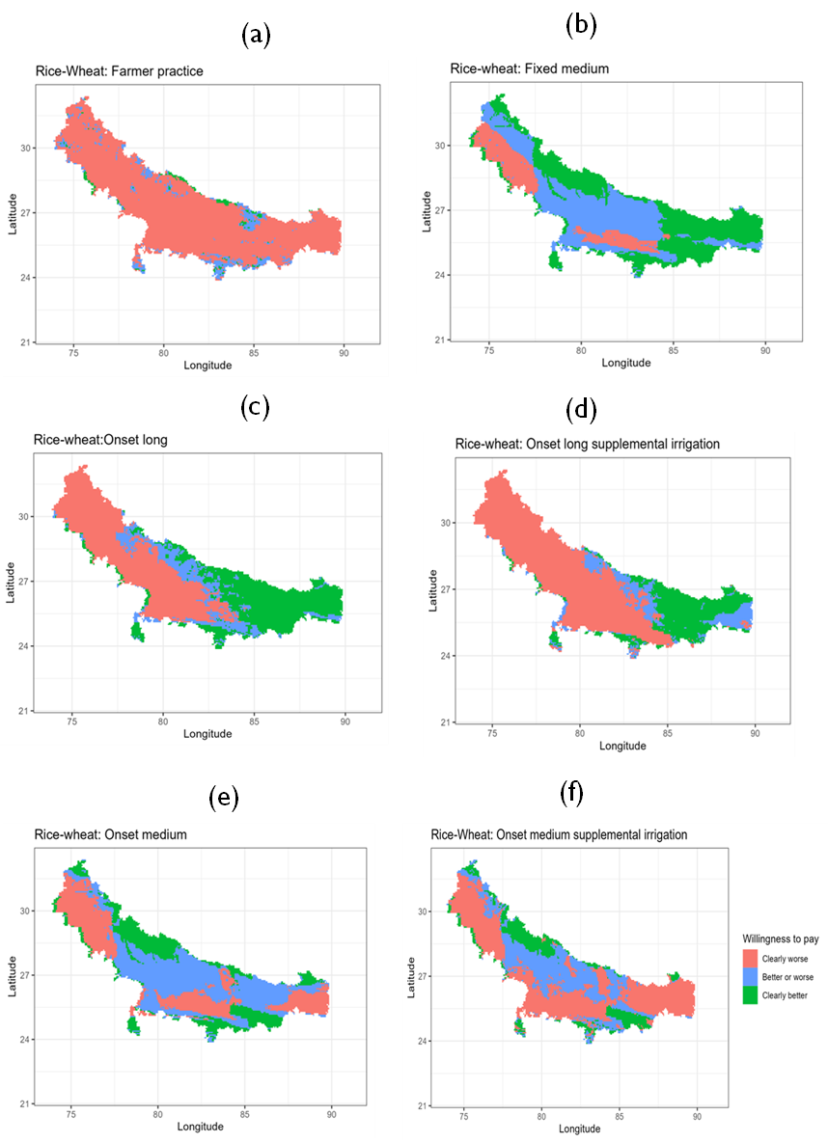

Figure 4: Spatial distribution of revenue WTP (where to target the scenarios)

### 3.2.2. System partial profits

Table 6 shows descriptive statistics for willingness to pay for partial profits (revenue-irrigation costs) for each of the planting date strategies as compared to fixed date-long duration rice variety strategy. As with productivity and revenue comparisons, farmer practice is a worse strategy for about 85% of the pixels in IGP. None of the strategies dominate across the entire IGP.

Table 6: Partial profits WTP (thousand rupees/ha) descriptive statistics

|  |  |  |  |  |  |  |  |
| --- | --- | --- | --- | --- | --- | --- | --- |
| Bound | Statistics | S0-S1 | S2-S1 | S3-S1 | S4-S1 | S5-S1 | S6-S1 |
| Upper bound | Mean | -15.31 | 40.40 | 12.30 | 7.84 | 23.80 | 25.40 |
| Std.Dev | 22.82 | 28.98 | 42.88 | 46.27 | 31.34 | 34.62 |
| Min | -97.77 | -25.01 | -80.65 | -95.69 | -62.89 | -82.90 |
| 10th percentile | -36.40 | -10.73 | -42.52 | -49.44 | -21.58 | -17.54 |
| 25th percentile | -26.88 | 24.88 | -16.26 | -27.25 | 7.19 | -1.91 |
| Median | -18.74 | 47.15 | 2.00 | 1.43 | 24.04 | 23.22 |
| 75th percentile | -8.09 | 62.14 | 48.44 | 41.74 | 48.21 | 52.55 |
| 90th percentile | 6.10 | 72.21 | 77.33 | 79.22 | 63.93 | 74.15 |
| Max | 99.85 | 96.57 | 103.13 | 112.42 | 137.49 | 129.42 |
| Lower bound | Mean | -50.40 | 3.51 | -16.12 | -24.19 | -8.78 | -5.70 |
| Std.Dev | 26.63 | 25.83 | 44.08 | 47.57 | 28.33 | 32.81 |
| Min | -126.29 | -54.20 | -115.70 | -112.73 | -103.66 | -118.82 |
| 10th percentile | -79.57 | -23.43 | -73.37 | -82.82 | -38.10 | -47.72 |
| 25th percentile | -66.27 | -16.27 | -54.83 | -66.11 | -23.19 | -23.23 |
| Median | -52.75 | -0.94 | -13.87 | -28.33 | -12.87 | -6.43 |
| 75th percentile | -35.94 | 20.98 | 16.24 | 13.97 | 6.85 | 12.31 |
| 90th percentile | -21.19 | 41.44 | 44.49 | 43.67 | 29.05 | 36.92 |
| Max | 89.66 | 76.40 | 90.44 | 97.08 | 120.33 | 99.99 |
| WTP summary | Clearly better (share) | 0.02 | 0.49 | 0.37 | 0.31 | 0.32 | 0.38 |
| Not clear (share) | 0.13 | 0.37 | 0.18 | 0.21 | 0.48 | 0.35 |
| Clearly worse (share) | 0.85 | 0.14 | 0.45 | 0.48 | 0.21 | 0.27 |
| Number of cells | 17420.00 | 17420.00 | 17420.00 | 17420.00 | 17420.00 | 17420.00 |

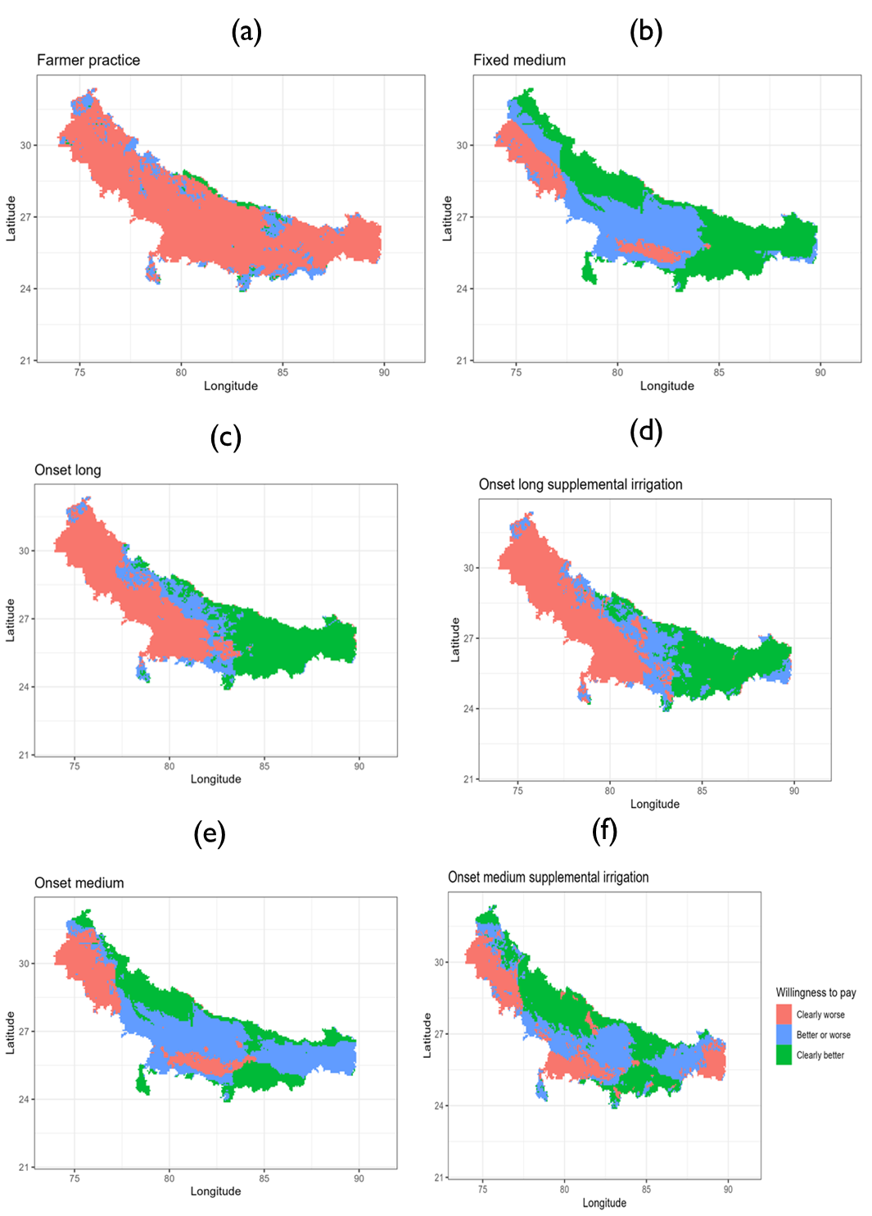

Figure 5: Spatial distribution of partial profit WTP (where to target the scenarios)

# 4. Recommended rice planting date strategy per grid cell

The foregoing analyses has made binary comparisons. But the interest is on which scenario should be advocated for a particular location. To get this optimal scenario, we calculate the maximum upper bound WTP among the scenarios and the maximum lower WTP. If there is match on which scenario is selected and are all positive, then we recommend that scenario. Figure 6 shows the optimal rice planting date strategy. This is main graph for the paper recommending a robust strategy for each pixel from the optimization model of partial profits.

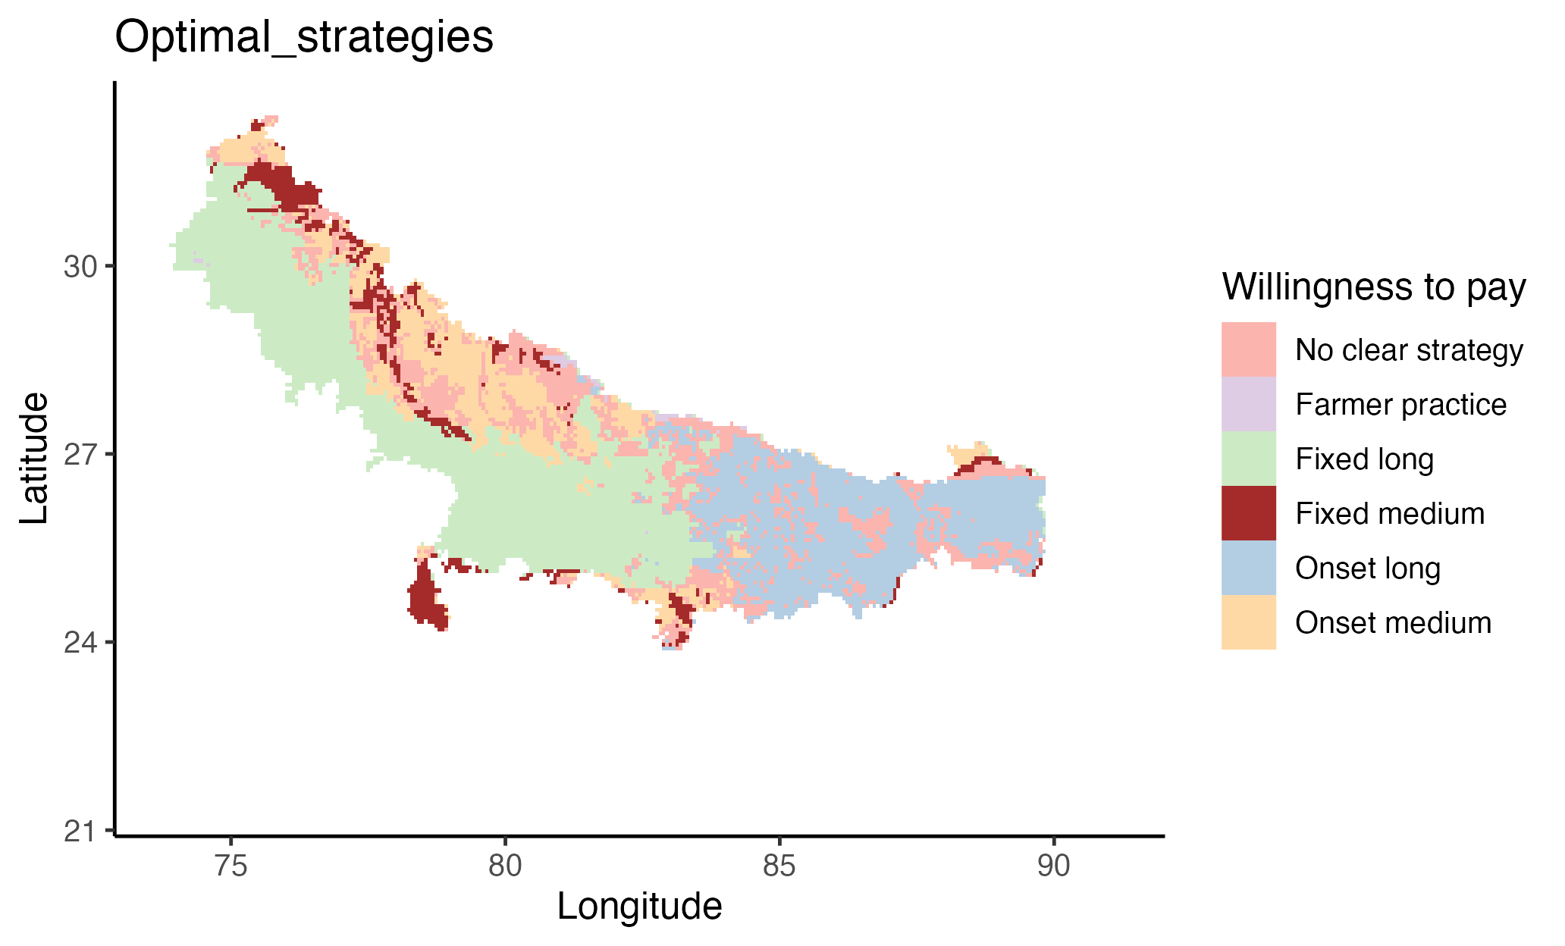

Figure 6: Optimal rice planting date strategy

Note: The strategies with suffix "clearly" have the maximum gains across all scenarios for both upper and lower bounds meaning that for all risk tolerances (risk aversion), this is the optimal strategy. The ones with the suffix "not clear" have the maximum upper bound but maximum lower bound is another strategy meaning only a risk neutral farmer will find this optimal. For risk averse farmers, it depends on their risk aversion (which we don't measure in this paper) to assign them a strategy in these locations.

# 5. Conclusion

Early sowing of rice has been proposed as the best strategy at optimizing productivity of rice-wheat rotation system in Bihar and the rest of the Indo-Gangetic Plains of India, Bangladesh, Nepal and Pakistan. Any cropping calendar adjustment is expected to be risky to the farmers and may be economically suboptimal. In this paper, we use an approach proposed by Hurley et al (2018) of using computational second order stochastic dominance to calculate lower and upper bounds for which any risk averse farmer will be willing to pay to adopt an alternative rice planting date strategy.

We find a substantial spatial variation in the optimal planting date strategies. Planting rice on a fixed date with a long duration variety is recommended for the western part of the IGP while planting rice at monsoon onset with a long duration variety is recommended for eastern part of the IGP.

# References

Hurley, T., Koo, J., and Tesfaye, K. 2018. “Weather risk: how does it change the yield benefits of nitrogen fertilizer and improved maize varieties in sub-Saharan Africa?” *Agricultural Economics* 49: 711-723. Doi: 10.1111/agec.12454.

Ishtiaque, A., Singh, S., Lobell, D., Singh, B., Fishman, R., and Jain, M. 2022. “Prior crop season management constrains farmer adaptation to warming temperatures: Evidence from the Indo-Gangetic Plains.” *Science of the Total Environment* 807 (2). Doi: [https://doi.org/10.1016/j.scitotenv.2021.151671](https://doi.org/10.1016/j.scitotenv.2021.151671" \t "_blank" \o "Persistent link using digital object identifier).

Levy, H. 2016. “Stochastic Dominance: Investment Decision Making under Uncertainty.” Third Edition. Springer.

Meyer, J.1977. “Second degree stochastic dominance with respect to a function.” *International Economic Review* 18(2): 477-487. Doi: <https://doi.org/10.2307/2525760>.

Montes, C., Urfels, A., Han, E., and Balwinder-Singh. 2022. “Planting rice at monsoon onset could mitigate the impact of temperature stress on rice-wheat systems of Bihar, India.” *Atmosphere* 14(1), 40. Doi:  <https://doi.org/10.3390/atmos14010040>.

McDonald, A.J., Balwinder-Singh., Keil, A., Srivastava, A., Craufurd, P., Kishore, A., Kumar, V., Paudel, G., Singh, S., Singh, A.K., Sohane, R.K., and Malik, R.K. 2022. “Time management governs climate resilience and productivity in the coupled rice-wheat cropping systems of eastern India.” Nature Food. Doi: <https://doi.org/10.1038/s43016-022-00549-0>.

Markowitz, H.M. 1959. “Portfolio selection: Efficient diversification of investments”. Cowles Foundation for Research in Economics. Yale University. Url: <https://cowles.yale.edu/sites/default/files/2022-09/m16-all.pdf>.

Nalley, L.L., and Barkley, A.P. 2010. “Using Portfolio Theory to Enhance Wheat Yield Stability in Low-Income Nations: An Application in the Yaqui Valley of Northwestern Mexico.” *Journal of Agricultural and Resource Economics* 35(2): 334-347. Url: <https://www.jstor.org/stable/41960521>.

Newport, D., Lobell, D.B., Singh, B., Srivastiva, A., Rao, P., Umashaanker, M., Malik, R.K., McDonald, A., and Jain, M. 2020. “Factors Constraining Timely Sowing of Wheat as an Adaptation to Climate Change in Eastern India.” *Weather, Climate and Society* 515-528. Doi: [https://doi.org/10.1175/WCAS-D-19-0122.1](https://doi.org/10.1175/WCAS-D-19-0122.1" \t "_blank).

Suri, T. 2011. “Selection and Comparative Advantage in Technology Adoption.” *Econometrica* 79(1): 159-209. Doi:10.3982/ECTA7749.

Urfels, A., McDonald, A.J., Halsema, G., Struik, P.C., Kumar, P., Malik, R.K., Poonia, S.P., Singh, B., Singh, D.K., Singh, M., Krupnik, T.J. 2021. “Socio-ecological analysis of timely rice planting in Eastern India.” *Agronomy for Sustainable Development* 41: 14. Doi: <https://doi.org/10.1007/s13593-021-00668-1>.

Urfels, A., Montes, C., Balwinder-Singh, Halsema, G., Struik, P., Krupnik, T., and McDonald, J. 2022. “Climate adaptative rice planting strategies diverge across environmental gradients in the Indo-Gangetic Plains.” *Environmental Research Letters* 17: 124030. Doi: 10.1088/1748-9326/aca5a2.

# Appendices

## Appendix A: Fixed long as baseline with zero yield entries, Bihar

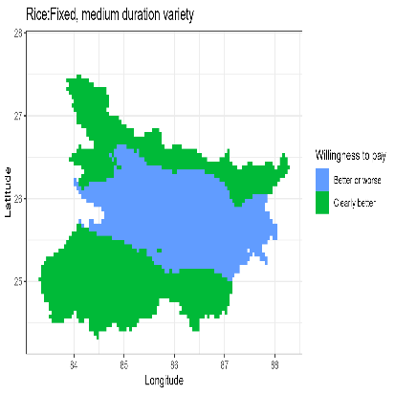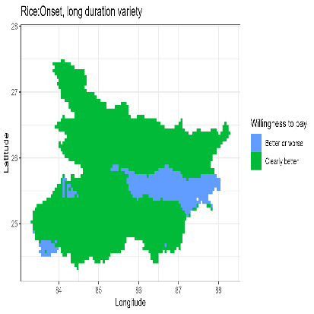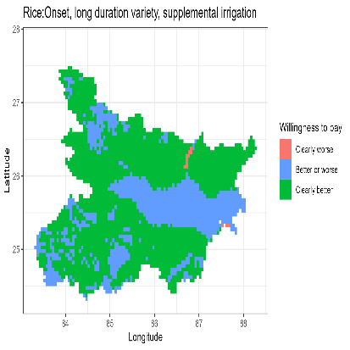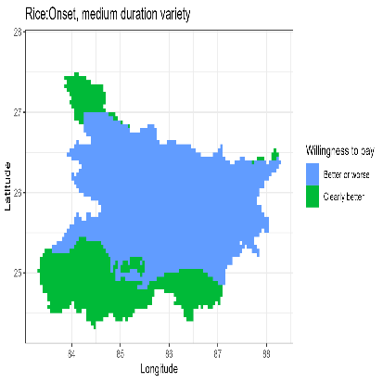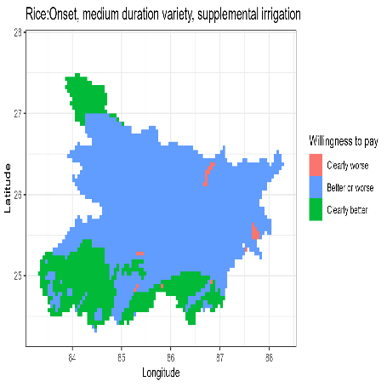

a

b

c

d

e

f

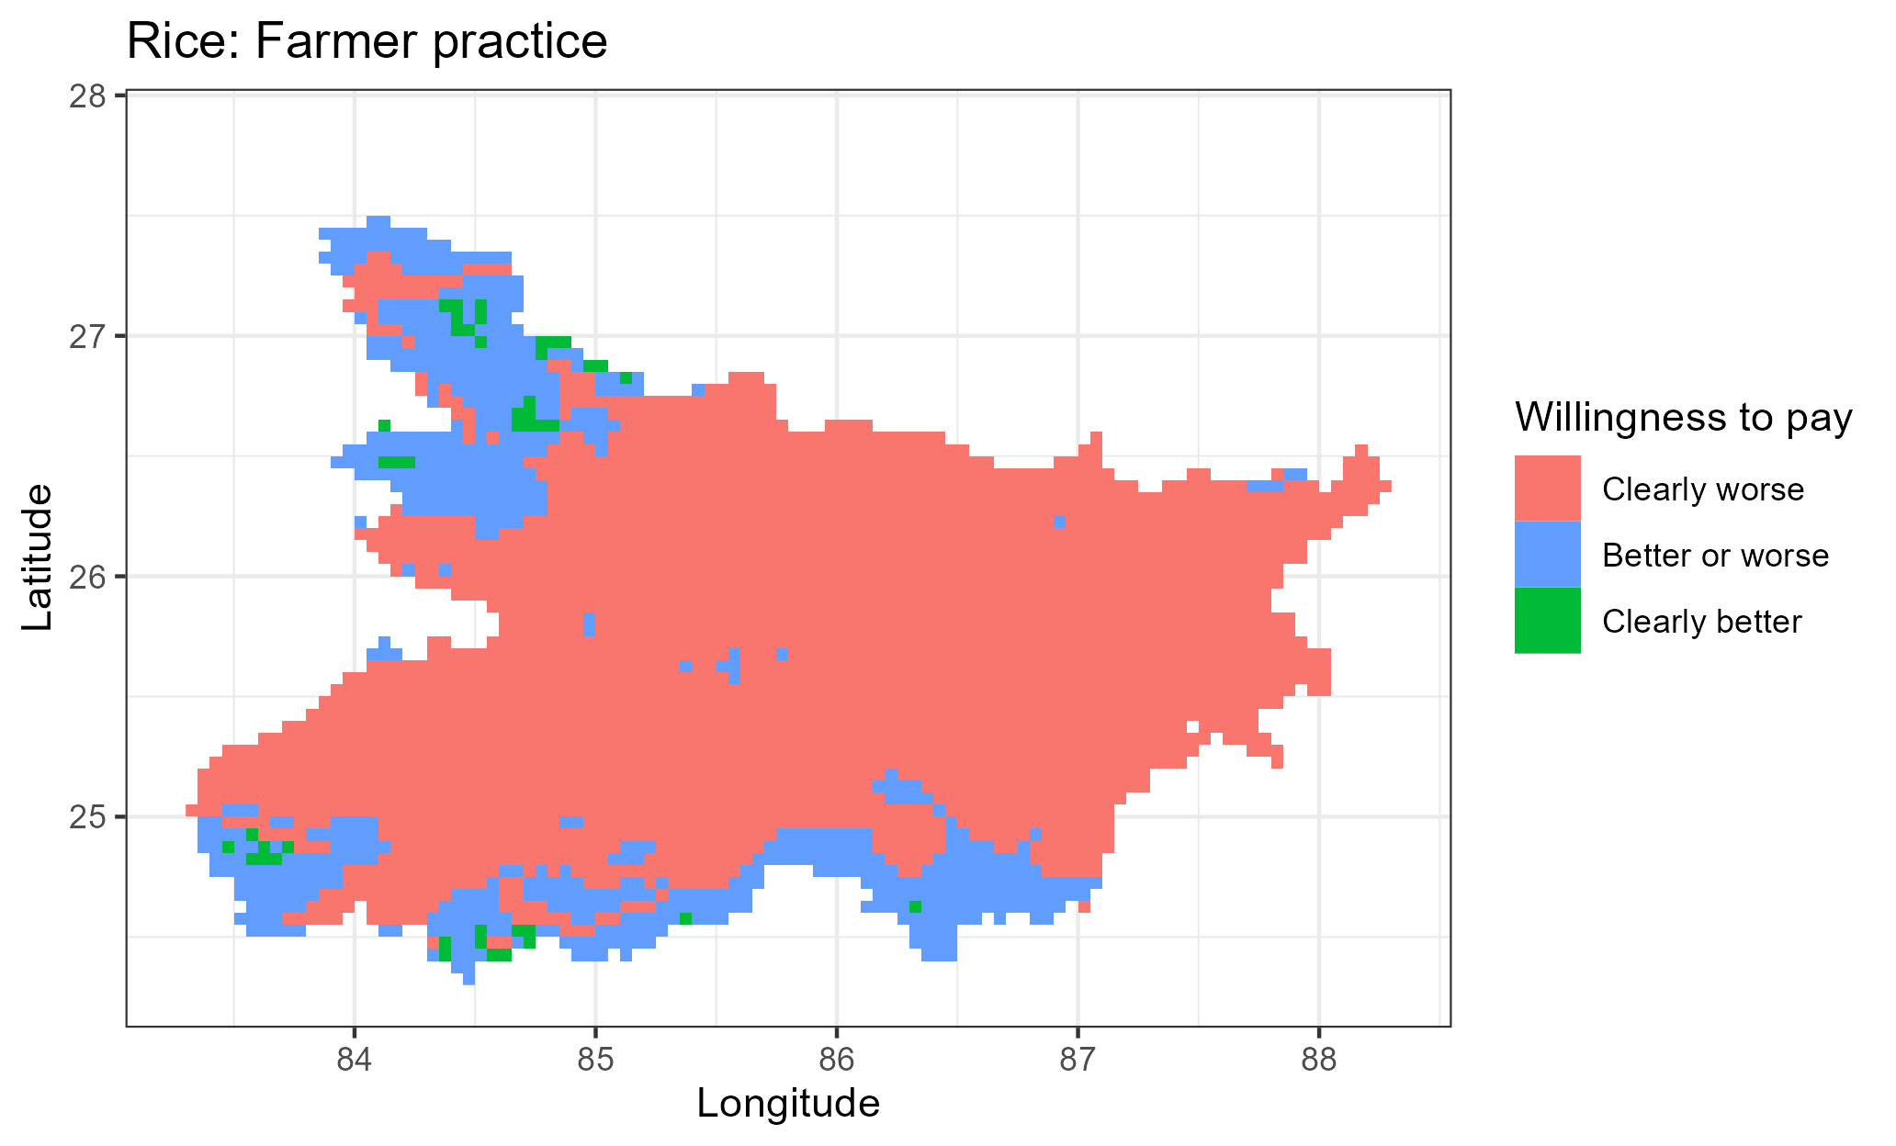

Figure A1: Rice WTP decisions as compared to fixed long strategy

a

b

c

d

e

f

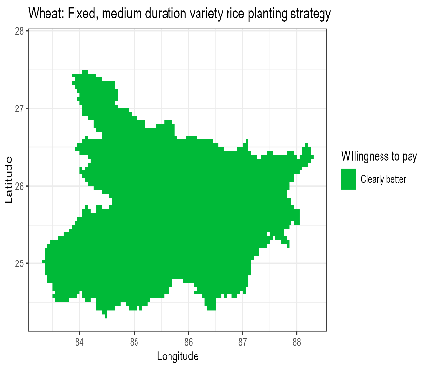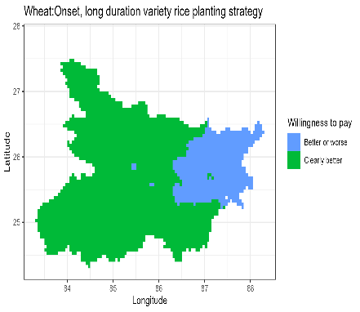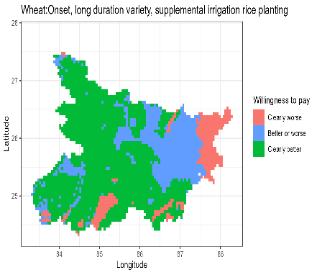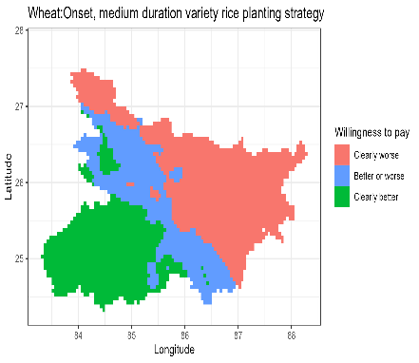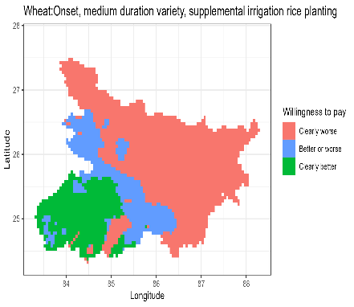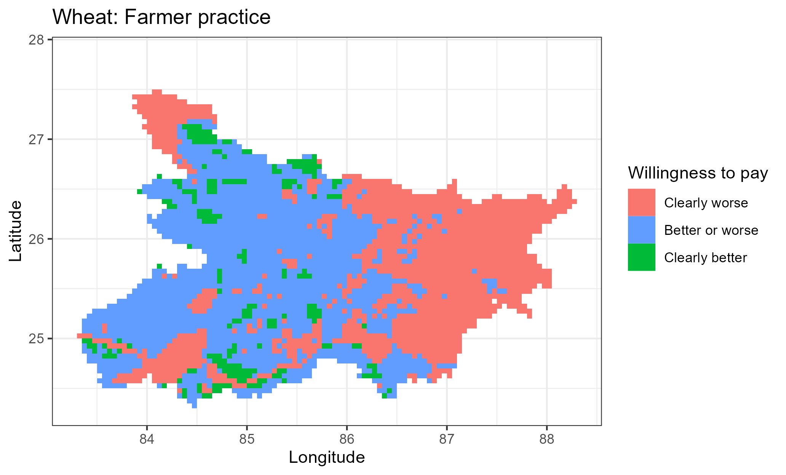

Figure A2: Wheat WTP decisions as compared to fixed long strategy

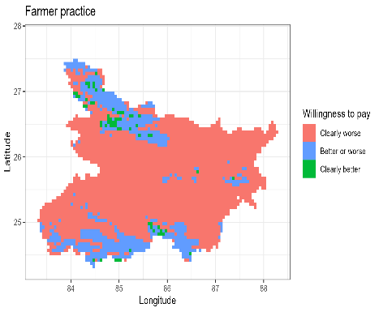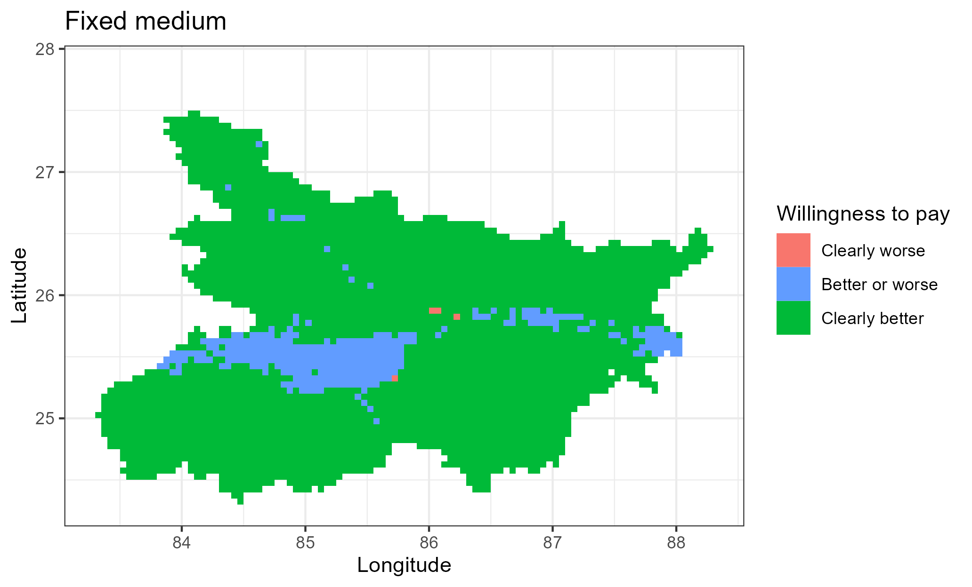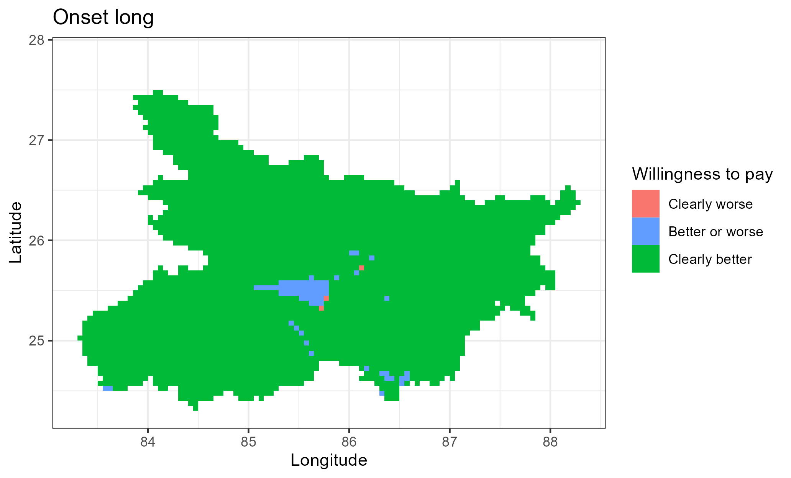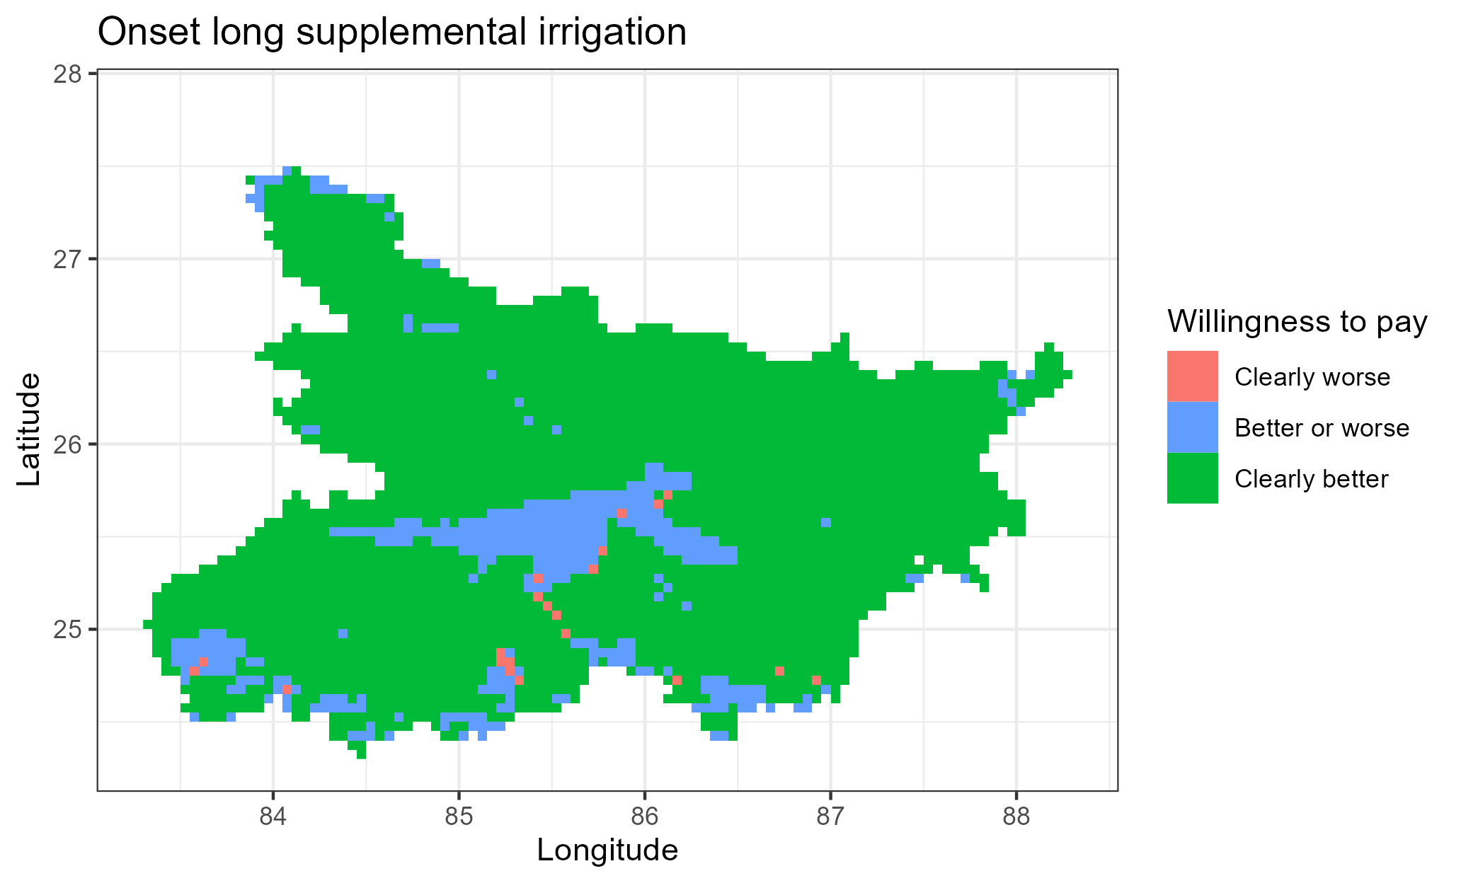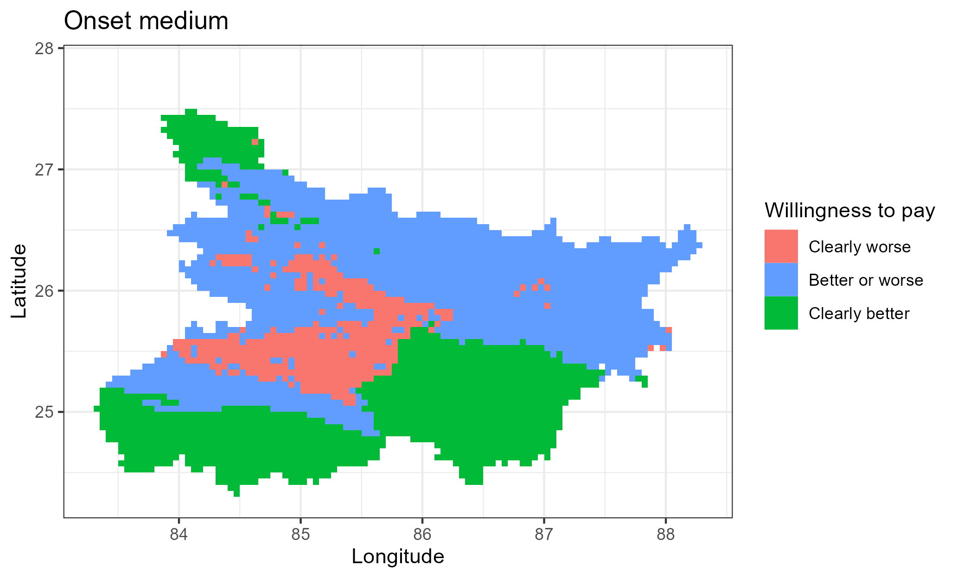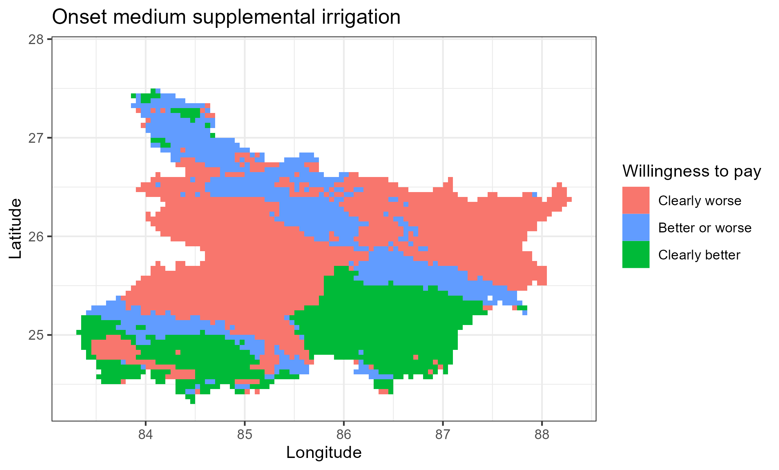

Figure A3: Revenue WTP decisions as compared to fixed long strategy

Table A1: Rice WTP bounds with fixed long as baseline [with zero yield entries], Bihar

|  |  |  |  |  |  |  |  |
| --- | --- | --- | --- | --- | --- | --- | --- |
| Bound | Statistics | S0-S1 | S2-S1 | S3-S1 | S4-S1 | S5-S1 | S6-S1 |
| Upper bound | Mean | -0.84 | 2.92 | 3.95 | 3.57 | 1.91 | 1.80 |
| Standard deviation | 1.57 | 0.41 | 0.62 | 0.63 | 0.35 | 0.45 |
| Min | -2.20 | 2.27 | 2.89 | -1.75 | 1.29 | -1.95 |
| 10th percentile | -1.92 | 2.50 | 3.18 | 3.03 | 1.55 | 1.45 |
| 25th percentile | -1.87 | 2.61 | 3.44 | 3.20 | 1.64 | 1.60 |
| Median | -1.69 | 2.79 | 3.85 | 3.48 | 1.84 | 1.79 |
| 75th percentile | -0.41 | 3.18 | 4.40 | 3.95 | 2.13 | 2.03 |
| 90th percentile | 1.86 | 3.49 | 4.85 | 4.37 | 2.40 | 2.31 |
| Max | 4.88 | 4.19 | 5.73 | 5.33 | 3.12 | 2.97 |
| Lower bound | Mean | -3.21 | 0.44 | 1.43 | 0.73 | -0.61 | -0.86 |
| Standard deviation | 1.44 | 1.38 | 1.23 | 1.18 | 1.33 | 1.28 |
| Min | -6.59 | -1.73 | -1.71 | -3.91 | -2.66 | -3.04 |
| 10th percentile | -5.31 | -1.31 | -0.10 | -0.44 | -2.24 | -2.29 |
| 25th percentile | -4.28 | -0.66 | 0.43 | -0.12 | -1.68 | -1.91 |
| Median | -3.08 | 0.25 | 1.29 | 0.57 | -0.84 | -1.14 |
| 75th percentile | -2.06 | 1.37 | 2.27 | 1.47 | 0.28 | -0.08 |
| 90th percentile | -1.82 | 2.68 | 3.25 | 2.39 | 1.49 | 1.20 |
| Max | 0.76 | 3.69 | 4.79 | 4.37 | 2.45 | 2.35 |
| WTP summary | Clearly better (share) | 0.01 | 0.57 | 0.87 | 0.69 | 0.29 | 0.24 |
| Not clear (share) | 0.19 | 0.43 | 0.13 | 0.30 | 0.71 | 0.75 |
| Clearly worse (share) | 0.79 | 0.00 | 0.00 | 0.00 | 0.00 | 0.01 |
| Number of cells | 3386.00 | 3386.00 | 3386.00 | 3386.00 | 3386.00 | 3386.00 |

Table A2: Wheat WTP bounds with fixed long as baseline, Bihar

|  |  |  |  |  |  |  |  |
| --- | --- | --- | --- | --- | --- | --- | --- |
| Bound | Statistics | S0-S1 | S2-S1 | S3-S1 | S4-S1 | S5-S1 | S6-S1 |
| Upper bound | Mean | -0.34 | 1.28 | 1.23 | 0.64 | 0.20 | -0.37 |
| Standard deviation | 0.98 | 0.12 | 0.38 | 0.69 | 0.76 | 1.03 |
| Min | -2.60 | 0.60 | 0.18 | -2.39 | -1.11 | -2.39 |
| 10th percentile | -1.98 | 1.15 | 0.64 | -0.09 | -0.80 | -1.78 |
| 25th percentile | -1.16 | 1.23 | 0.98 | 0.48 | -0.37 | -1.22 |
| Median | 0.05 | 1.30 | 1.29 | 0.75 | 0.11 | -0.36 |
| 75th percentile | 0.32 | 1.37 | 1.50 | 1.04 | 0.82 | 0.47 |
| 90th percentile | 0.59 | 1.40 | 1.65 | 1.25 | 1.32 | 1.10 |
| Max | 1.59 | 1.53 | 2.05 | 1.91 | 1.69 | 1.61 |
| Lower bound | Mean | -1.71 | 1.03 | 0.66 | 0.04 | -0.24 | -1.15 |
| Standard deviation | 1.23 | 0.12 | 0.61 | 0.90 | 0.78 | 1.10 |
| Min | -3.72 | 0.38 | -0.89 | -3.47 | -1.42 | -3.72 |
| 10th percentile | -3.13 | 0.88 | -0.26 | -1.04 | -1.08 | -2.18 |
| 25th percentile | -2.64 | 0.98 | 0.23 | -0.34 | -0.87 | -1.88 |
| Median | -2.11 | 1.06 | 0.78 | 0.25 | -0.47 | -1.60 |
| 75th percentile | -0.01 | 1.11 | 1.17 | 0.64 | 0.36 | -0.49 |
| 90th percentile | 0.00 | 1.15 | 1.34 | 0.93 | 1.07 | 0.81 |
| Max | 1.34 | 1.24 | 1.62 | 1.49 | 1.35 | 1.23 |
| WTP summary | Clearly better (share) | 0.06 | 1.00 | 0.80 | 0.64 | 0.31 | 0.19 |
| Not clear | 0.52 | 0.00 | 0.20 | 0.25 | 0.25 | 0.19 |
| Clearly worse (share) | 0.42 | 0.00 | 0.00 | 0.11 | 0.44 | 0.62 |
| Number of cells | 3386.00 | 3386.00 | 3386.00 | 3386.00 | 3386.00 | 3386.00 |

Table A3: Revenue WTP descriptive, Bihar

|  |  |  |  |  |  |  |  |
| --- | --- | --- | --- | --- | --- | --- | --- |
| Bound | Statistics | S0-S1 | S2-S1 | S3-S1 | S4-S1 | S5-S1 | S6-S1 |
| 1 | 2 | 3 | 4 | 5 | 6 | 7 | 8 |
| Upper bound | Mean | -20013.05 | 55883.71 | 63616.27 | 49155.51 | 20429.77 | 7515.66 |
| Standard deviation | 32655.19 | 9074.47 | 17482.79 | 18110.54 | 18591.31 | 22571.44 |
| Min | -95787.35 | -10517.52 | -4369.18 | -19391.88 | -39021.17 | -50886.52 |
| 10th percentile | -59656.73 | 43928.94 | 38320.78 | 24205.65 | -867.53 | -16172.84 |
| 25th percentile | -51206.99 | 49765.59 | 49675.54 | 36655.93 | 4862.05 | -10466.29 |
| Median | -20973.23 | 56612.31 | 66844.77 | 52036.13 | 17028.43 | 228.33 |
| 75th percentile | -4138.39 | 62657.69 | 77845.09 | 63242.54 | 35833.15 | 26593.53 |
| 90th percentile | 24233.15 | 66609.76 | 85588.52 | 70133.90 | 49660.69 | 43570.32 |
| Max | 81513.61 | 77485.07 | 99480.34 | 88532.49 | 65034.09 | 61649.20 |
| Lower bound | Mean | -65401.51 | 22156.76 | 34908.06 | 19381.06 | -5512.13 | -15873.31 |
| Standard deviation | 30942.86 | 18377.46 | 19462.07 | 19031.29 | 24394.58 | 25250.42 |
| Min | -155222.24 | -30504.21 | -22649.54 | -49949.50 | -50621.89 | -67245.17 |
| 10th percentile | -106733.31 | 181.31 | 10065.78 | -2004.77 | -35187.29 | -46957.71 |
| 25th percentile | -89550.75 | 8369.37 | 20432.33 | 8001.31 | -24179.36 | -35355.27 |
| Median | -66430.47 | 19168.12 | 33537.89 | 18166.67 | -11178.09 | -19318.34 |
| 75th percentile | -44071.09 | 34650.94 | 48244.30 | 30751.22 | 13467.91 | 1582.32 |
| 90th percentile | -22426.40 | 50199.19 | 62462.09 | 45209.79 | 30279.24 | 19949.24 |
| Max | 77859.21 | 67605.46 | 84539.77 | 74983.11 | 55539.64 | 52194.78 |
| WTP summary | Clearly better (share) | 0.02 | 0.90 | 0.98 | 0.88 | 0.37 | 0.26 |
| Not clear (share) | 0.20 | 0.09 | 0.02 | 0.12 | 0.51 | 0.24 |
| Clearly worse (share) | 0.78 | 0.00 | 0.00 | 0.01 | 0.13 | 0.49 |
| Number of cells | 3429.00 | 3429.00 | 3429.00 | 3429.00 | 3429.00 | 3429.00 |

## Appendix C: Price sensitivity, Bihar

The analyses so far have focused on productivity gains to rice planting date adjustment. However, cost of production may also be affected by these adjustments. The changes in the cost of production may be due to direct changes in the inputs (e.g., alternative variety may be more expensive, sowing labor or hired machinery may be costly during the proposed sowing dates or irrigation may be costly). The changes may also be due to indirect changes in the production system. For example, sowing a long duration variety may require more irrigation which then increases irrigation costs. There are no studies that compute these costs comprehensively. We therefore test the robustness of the decisions on which strategy is beneficial to the farmers by using multiple of cost-output price ratios.

To test the robustness of the willingness to pay measures, we conduct a simple sensitivity analysis in which we vary the differential input price ratio of cost of the proposed rice planting strategy to the output prices. This is given by

$$kg of wheat (or rice) required to pay for planting date adjustment per ha(kg/ha)=\frac{Total cost of rice planting strategy adjustment per ha \left(\frac{Rs}{ha}\right) }{Price of wheat (or rice) per kg (\frac{Rs}{kg})}$$

Figure C1 shows the percentage distribution of risk averse farmers who would prefer that strategy as compared to the fixed long rice planting given increase input cost-output price ratio. At zero input cost changes, the percentage of farmers who prefer the corresponding strategies are as in table 2 and table 3. Panel (a) of Figure 4 shows that wheat is more responsive to changes in the costs of production as compared to rice. Overall, the ordering of the strategies remains intact with constant changes in costs of production except for implausibly high costs of production.

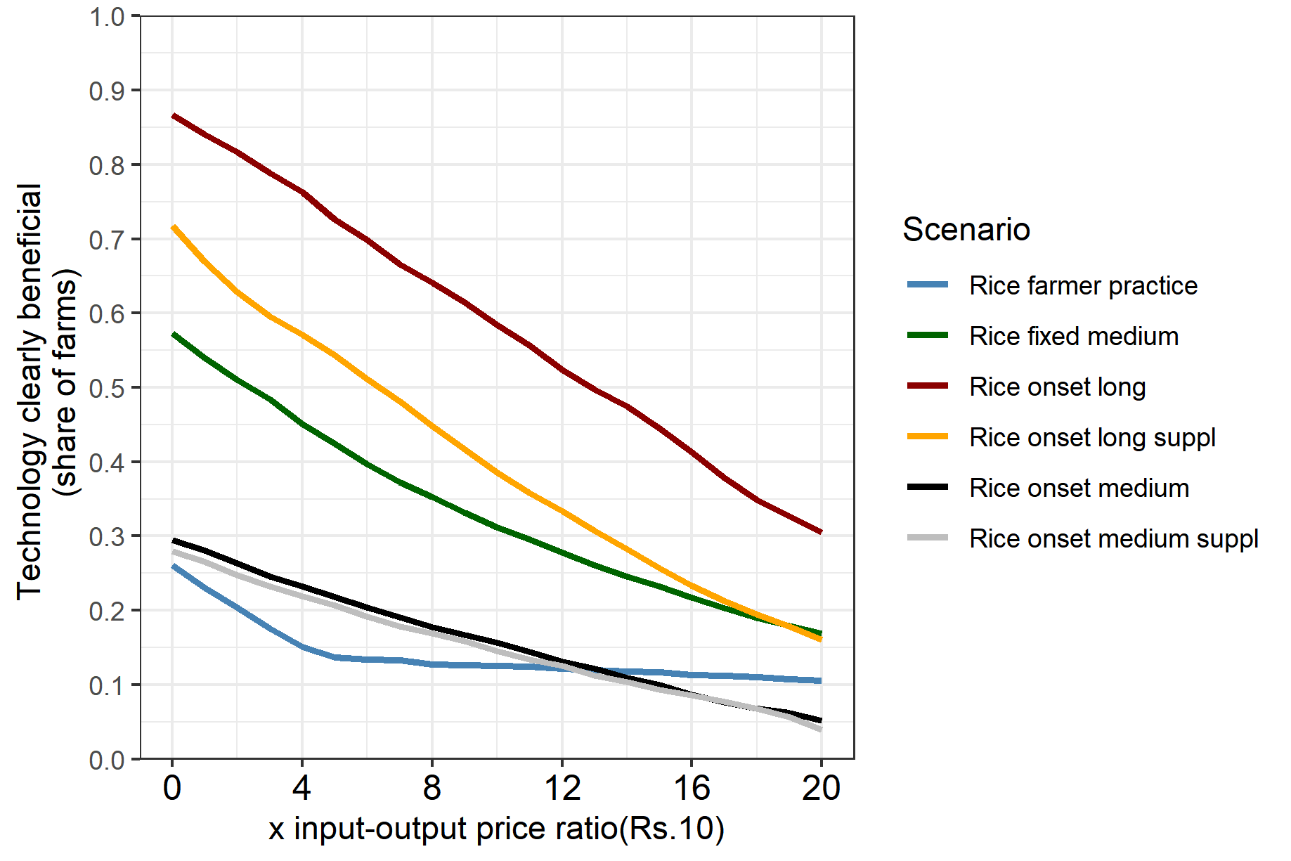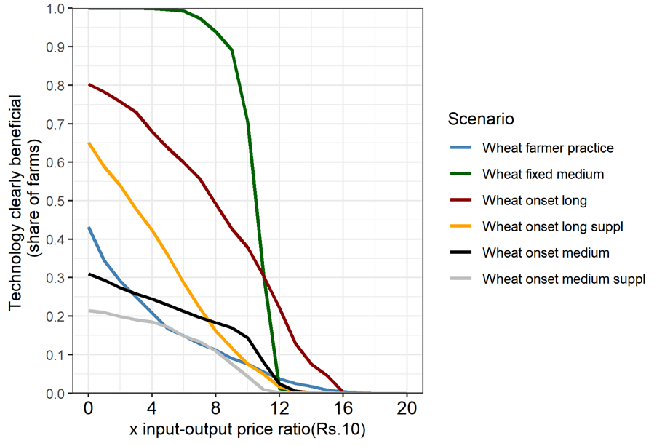

a. Without zero yield entries

Rice

Wheat

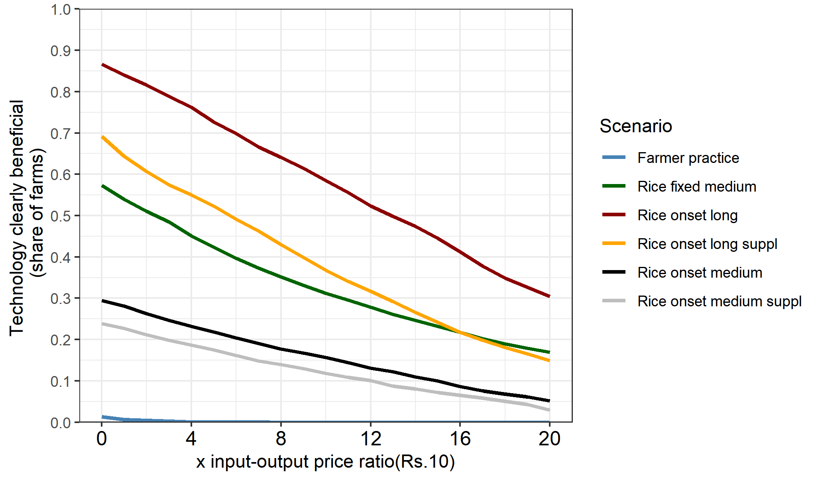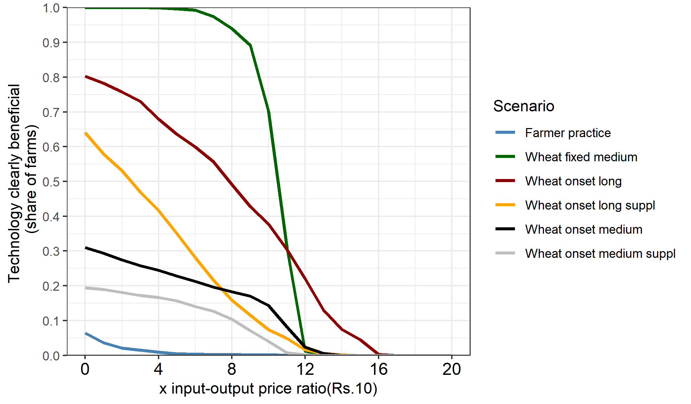

b. With zero yield entries

Rice

Wheat

Figure C1: Price sensitivity

1. The gridded APSIM crop simulation model setup and results are available here: <https://git.wageningenur.nl/urfel001/igp-simulation-setup>. [↑](#footnote-ref-2)